**FLORIDA ENERGY SYSTEM CONSORTIUM WEBSITE REDESIGN**

Objective/purpose of the redesign:

Evaluate the FESC website (<http://floridaenergy.ufl.edu/>) and recommend website improvements to increase improve website functionality and performance.

Landing page screen shot:

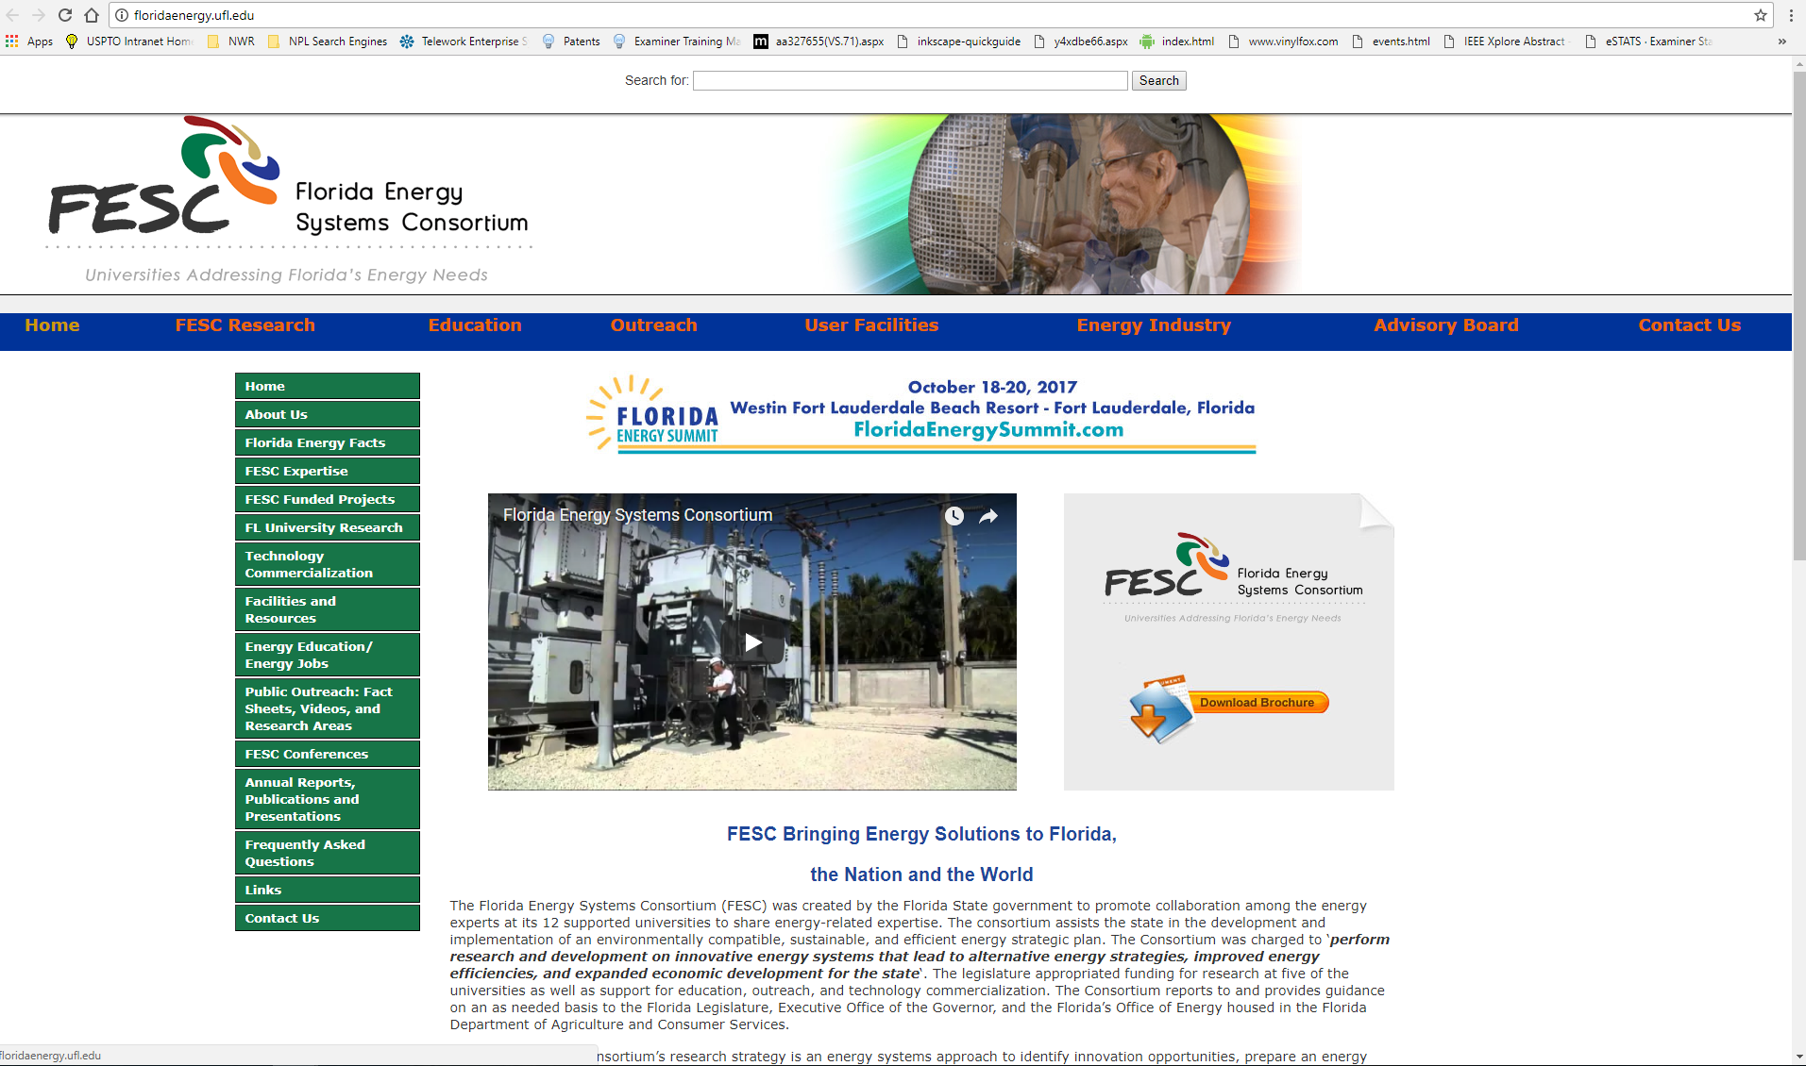

Thoughts on functionality and ease of use:

The website uses two different navigation bars to direct you throughout the website. A top horizontal navigation bar directs you to a specific search area (e.g., Home, FESC Research, etc), while a vertical navigation bar on the right provides information related to the topic selected with the horizontal navigation bar.

Resources:

<https://www.toptal.com/designers/colorfilter>

<http://wave.webaim.org/report#/http://floridaenergy.ufl.edu/>

<https://www.powermapper.com/products/sortsite/checks/accessibility-checks/>

<https://validator.w3.org/>

<http://browsershots.org/>

<https://tools.pingdom.com/#!/bHbogR/http://floridaenergy.ufl.edu/>

<https://gtmetrix.com/reports/floridaenergy.ufl.edu/z3UGGmsR>

<https://developers.google.com/speed/pagespeed/insights/>

<https://developers.google.com/speed/>

<https://varvy.com/>

<https://www.found.co.uk/seo-tool/>

<https://www.woorank.com/en/www/floridaenergy.ufl.edu>

<http://tools.neilpatel.com/en/analyze/http%3A%2F%2Ffloridaenergy.ufl.edu%2F#!/>

<https://neilpatel.com/seo-analyzer/>

<http://nibbler.silktide.com/en_US/reports/floridaenergy.ufl.edu>